REFLECTED XSS EXPLOITATION
Project: Internship Onboarding and Environment Setup
Student: Mbainlakong Josephine
1. Introduction
Cross-Site Scripting (XSS) is a security problem in websites. It happens when a website takes what a user types and shows it back without checking it. The browser then thinks it is code and runs it.
In this practical, I used DVWA to test this problem in a safe lab. DVWA is a website made for learning.
2. Objective
I wanted to:
Find a Reflected XSS problem.
Check if what I type is shown back on the page.
Show that JavaScript can run with a simple alert.
Understand why this problem happens.
Learn how to stop it.
3. Tools Used
Kali Linux
DVWA
Web Browser like Firefox
VirtualBox for safe testing
4. Procedure
Step 1 - Configure DVWA
I opened DVWA and set the security level to Low.
Step 2 - Open Reflected XSS
I went to XSS (Reflected) in DVWA.
I typed a normal name like TestUser and clicked submit. The page showed TestUser back to me. This means the input is reflected.
Screenshot - Input Reflected
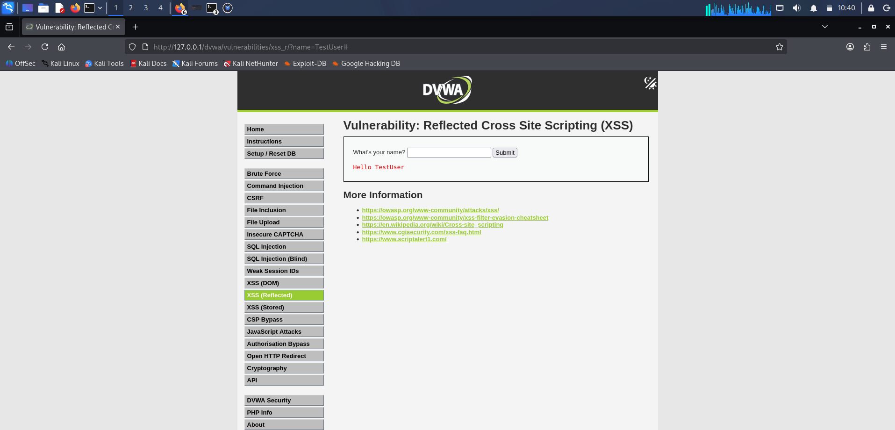

Step 3 - Test JavaScript Execution
Then I typed this:
<script>alert('Reflected XSS')</script>
I clicked submit and a small popup appeared with the message Reflected XSS.
This shows the website ran my JavaScript. This is the vulnerability.
Screenshot 3 - XSS Alert Popup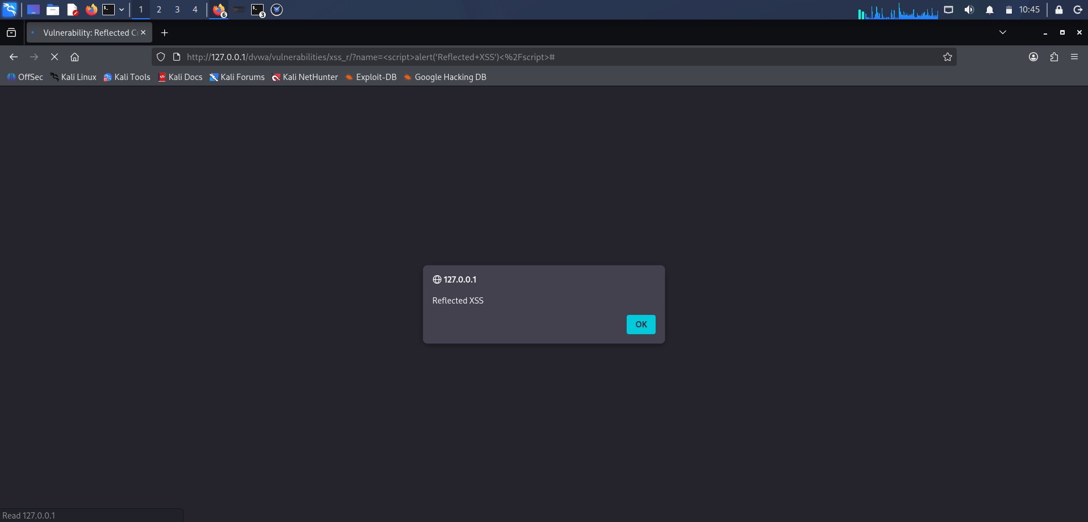

5. Why It Happens
It happens because the website does not clean user input before showing it. It takes the input and puts it directly into the page.
The flow is:
User types input, website receives it, website shows it back, browser runs it as code.
6. What Can Happen In Real Life
In a real website, an attacker can send a bad link to a victim. When the victim clicks it, the bad code runs in their browser. It can change the page or do things without permission.
I only tested this in DVWA lab, not on a real website.
7. How To Fix It
To fix it:
Clean user input before showing it on the page.
Check and allow only safe characters.
Do not put user input directly inside JavaScript code.
Use Content Security Policy (CSP) to block bad scripts.
Protect cookies with HttpOnly, Secure, and SameSite.
8. Conclusion
I was able to show Reflected XSS in DVWA using a simple alert. The test shows that if a website does not clean user input, an attacker can run JavaScript.
This practical taught me why cleaning input and encoding output is important to keep websites safe.

